Planning Logic — Incident UI Policy & Client Script Project
Implement Client Script & UI Policy (Incident)
Date: 01 October 2026 | Team ID: SWTID-2026-4755
This plan breaks the micro-project into small, testable stories so that each ServiceNow control can be configured, verified, and documented without losing sight of the agent experience.

Planning assumptions
• One small delivery team with ServiceNow configuration access.
• Two six-day sprints with 32 planned story points in total.
• A story is considered complete only when the configuration is saved and the related test scenario passes.
• Client-side controls improve usability and consistency; platform roles and ACLs remain the security boundary.

Sprint 1 — Foundation and high-impact controls
Epic | Story | Outcome | Points | Definition of done
Incident policy | USN-1: Create High Impact Control UI Policy | Impact = 1 – High activates the policy. | 3 | Condition, active flag, reverse-if-false, and table are verified.
Incident policy | USN-2: Make Assignment group mandatory | High-impact records require a routing group. | 3 | UI Policy Action is mandatory and reverses when Impact changes.
Urgency automation | USN-3: Auto-set Urgency on change | Urgency becomes High when Impact becomes High. | 5 | onChange script sets urgency and shows the info message.
Save validation | USN-4: Require Assigned To on submit | Incomplete high-impact records cannot save. | 5 | onSubmit shows the field error and returns false.

Sprint 2 — Workflow safety, testing, and handoff
Epic | Story | Outcome | Points | Definition of done
Workflow safety | USN-5: Block State list editing | State cannot be changed directly in a list. | 3 | onCellEdit alerts the user and calls callback(false).
Verification | USN-6: Test mandatory enforcement and success path | Blocked save and valid save are both confirmed. | 3 | Test evidence records expected UI behavior.
Verification | USN-7: Test reverse condition and form update | Temporary controls reverse; form updates remain allowed. | 4 | Impact change and form-based State update pass.
Documentation | USN-8: Package configuration and handoff notes | Admins can understand and maintain the solution. | 6 | Names, messages, scripts, test checklist, and conclusion are documented.

Velocity and completion logic
Planned points = 16 in Sprint 1 + 16 in Sprint 2 = 32 points. Planned velocity = 32 / 2 = 16 story points per sprint. The burndown chart is a planned reference line, not a claim about actual completed work.
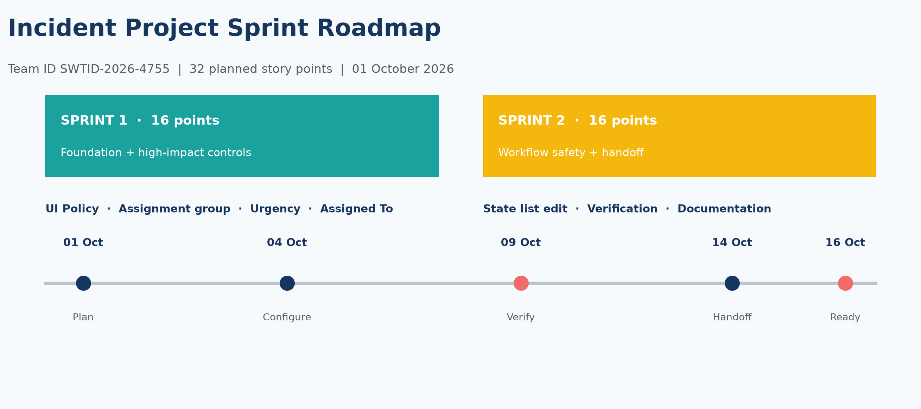
Generated project visual: Incident sprint roadmap for 32 planned story points.
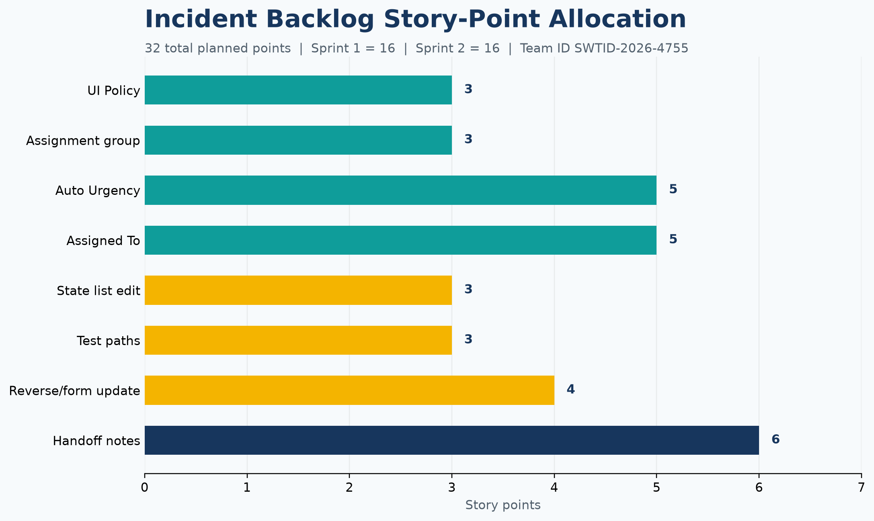
Generated project visual: precise Incident backlog story-point allocation.

Risks and responses
• Risk: client-side validation is treated as a security control. Response: retain ACLs and server-side policies as the authorization boundary.
• Risk: high-impact rules frustrate agents. Response: use clear messages, only activate controls when Impact is High, and reverse them when false.
• Risk: behavior is tested only on new records. Response: include existing-record, reverse-condition, list-edit, and form-update tests.

